**Iteration Two**  
**CIS 320**

**Team Left $ide**

**Sean O’Farrell, Brandon Mattingly, Matthew Lancaster, Ricardo Canales Gonzalez, Brandon Hall, Andrew Passanisi, Dillon Drees**

**System Request: Louisville Men’s Basketball Team**

The Louisville Men’s basketball team needs a simpler way to compile the data collected on their players and have ways to analyze that data. The project will supply a way to securely store data through a database server, have easier access to the data, and can transfigure the data in ways to help the team. This system will allow the team to use their statistical workings to their benefit and improve the effectiveness of their departments.  
**Sponsor:** The project overseer who will be connected to the basketball team.

The sponsor of this project is Dr. Hatami

**Business Need:** The reason the system is being created.

* Increase the accessibility to all departments' statistics.
* Transfer statistical operations from excel sheets to cloud-based database
* Allow for specific system configurations to restrict users access to specific department statistics.

**Business Want:** The specific attributes the system will need.

* Central system that has different sections to hold statistical information for every player.
* Statistical comparison and the ability to create informative documents.
* System security that will regulate the access to certain database sectors.

**Business Value:** The benefits that the new system will bring

* Expand ability to access statistical data
* Increased organization of all data from specific departments
* Increased ability to improve the team through statistical analysis
* Increased security for statistical operations

**Constraints:** Issues to be considered when implementing the system.

* Training will be needed to teach users how to use the system
* Database security is a key feature that will need to be kept up due to the importance of information
* Project due date: 04/24/23

**Process Model**

**As-is Model**

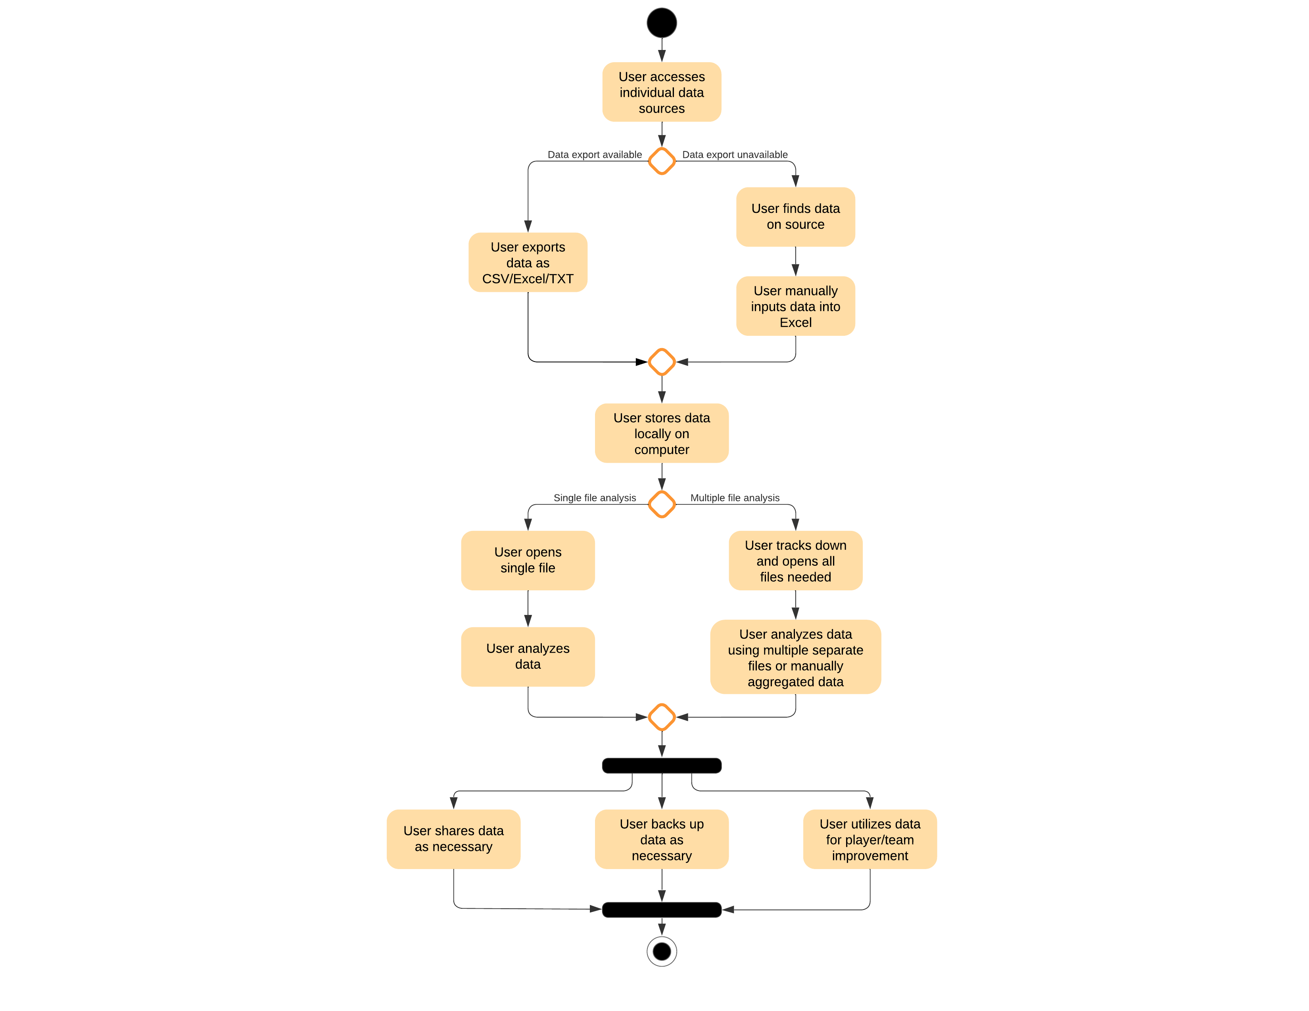

**Process Model**

**To-be Model**

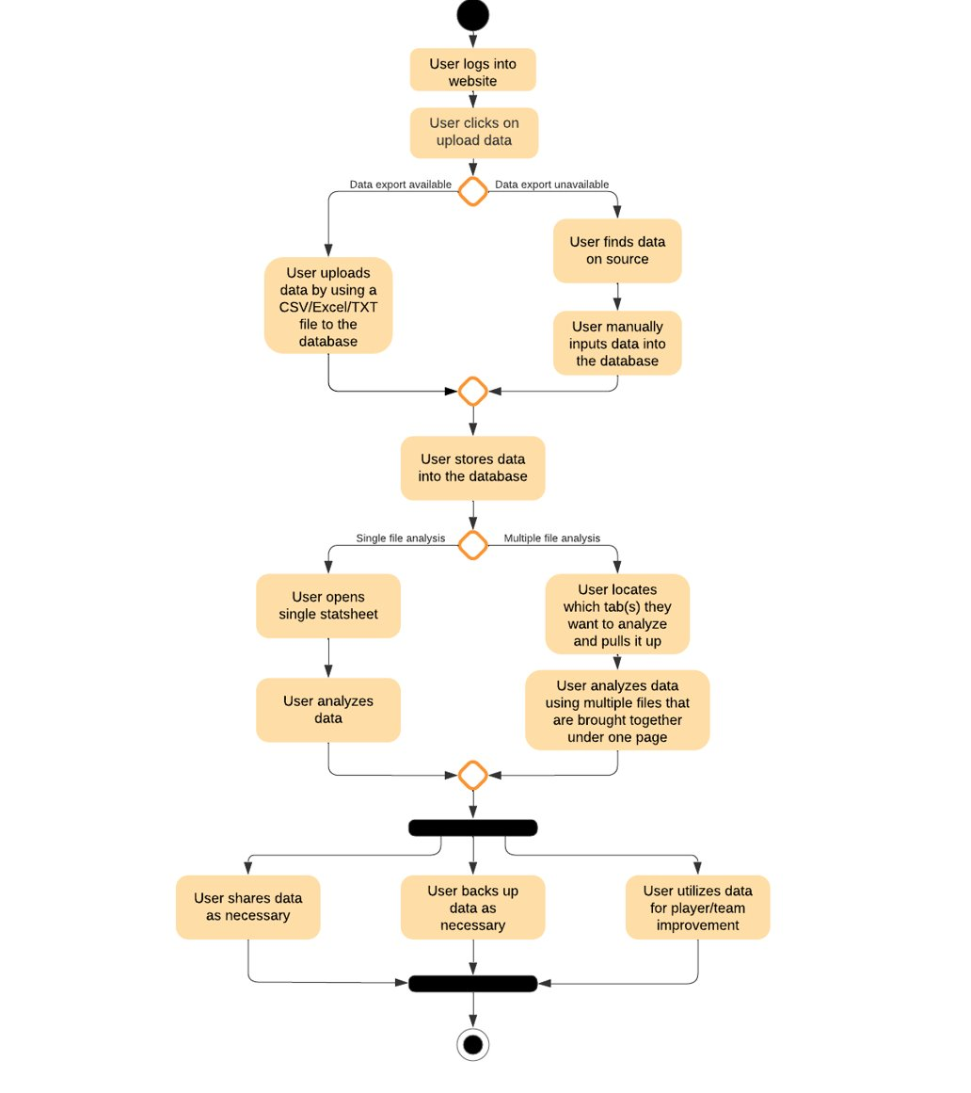

**UofL Men’s Basketball Team System Project**

**Vision (Small Project)**

**Version 2.0**

**Revision History**

|  |  |  |  |
| --- | --- | --- | --- |
| **Date** | **Version** | **Description** | **Author** |
| 18/Feb/23 | 1.0 | Vision document first draft | Sean O’Farrell, Brandon Mattingly, Matthew Lancaster, Ricardo Canales Gonzalez, Brandon Hall, Andrew Passanisi, Dillon Drees |
| 25/Feb/23 | 2.0 | Vision document second draft | Sean O’Farrell, Brandon Mattingly, Matthew Lancaster, Ricardo Canales Gonzalez, Brandon Hall, Andrew Passanisi, Dillon Drees |
| 26/Mar/23 | 3.0 | Vision document third draft | Sean O’Farrell, Brandon Mattingly, Matthew Lancaster, Ricardo Canales Gonzalez, Brandon Hall, Andrew Passanisi, Dillon Drees |
|  |  |  |  |

**Table of Contents**

1. Introduction 9

1.1 References 9

2. Positioning 9

2.1 Problem Statement 9

2.2 Product Position Statement 10

3. Stakeholder and User Descriptions 10

3.1 Stakeholder Summary 10

3.2 User Summary 11

3.3 User Environment 11

3.4 Summary of Key Stakeholder or User Needs 12

3.5 Alternatives and Competition 12

4. Product Overview 13

4.1 Product Perspective 13

4.2 Assumptions and Dependencies 13

5. Product Features 14

6. Other Product Requirements 14

7. Feasibility Analysis 15

8. Appendix A 36

**Vision (Small Project)**

# 1. Introduction

The purpose of this document is to collect, analyze, and define high-level needs and features of the SilverStripe CMS for the UofL men’s basketball team. It focuses on the capabilities needed by the stakeholders and the target users, and **why** these needs exist. The details of how the Silverstripe CMS fulfills these needs are detailed in the use-case and supplementary specifications. This document will include the business issue, stakeholders, users, as well as the result product that will be implemented.

# 2. Positioning

## 2.1 Problem Statement

|  |  |
| --- | --- |
| The problem of | - No centralized database  - Low availability for all statistics and health analysis of players  - Lacking system configuration for specific access for users |
| affects | - Louisville basketball players  - Louisville basketball coaches and staff |
| the impact of which is | - Hindering the basketball team from growing as an organization  - Difficulty supporting individual player improvement |
| a successful solution would be | - Improve the health of individuals as well as the team  - Will allow all players to reach their peak performance |

## 2.2 Product Position Statement

|  |  |
| --- | --- |
| For | UofL Men's Basketball Team |
| Who | Needs to store and analyze various player/team stats and information to ensure their team can perform at peak potential |
| The (product name) | Silverstripe CMS |
| That | Will help the basketball team track players progress in one centralized database |
| Unlike | The system they are using now, in which they must search 4 or 5 different databases for player information/statistics |
| Our product | It will help players grow as individuals, but will also impact the basketball team for years to come with all the information necessary available at their fingertips |

# 3. Stakeholder and User Descriptions

The UofL men’s baseball team is having issues with their player data due to all of the information being stored in different locations. Currently there are multiple sources of information that is being looked used (including practice statistics, game statistics, health status, etc.) and Justin Perez has asked us to build a centralized database where the coaching staff can view all the information in one location. This project will provide the team with their own centralized database that will give the coaching staff access to all the information that they need.

## 3.1 Stakeholder Summary

|  |  |  |
| --- | --- | --- |
| Name | Description | Responsibilities |
| Justin Perez | UofL Men’s Basketball Chief of Staff | Justin Perez and the rest of the coaching staff are tired of having to search multiple databases for the necessary information of players. Justin has asked us to create a secure database with all the information on players. Once the database is created, it is Justin and the rest of the coaching staff’s role to plug in the information of each practice, game, injury, sickness, etc. |

## 3.2 User Summary

|  |  |  |  |
| --- | --- | --- | --- |
| **Name** | **Description** | **Responsibilities** | **Stakeholder** |
| Trainers and Managers | Those who will be inputting the data into the system | - Input player practice and game statistics  - Plug in player health status including injury, questionable, etc. | - UofL Men’s Team Coaching Staff  - Men’s Team Players |

## 3.3 User Environment

As it stands currently, the team solely relies on Excel spreadsheets for sports statistics keeping. This can be a tedious and error-prone process, especially for teams with substantial amounts of data. By transitioning to a private Model-View-Controller (MVC) application, the team can streamline their stats keeping process, making it more efficient and effective. The new app will offer advanced features for data organization and analysis, with real-time updates that will help team members and coaches make informed decisions. The accuracy of the app's automated updates eliminates the risk of manual errors that are common in Excel spreadsheets. The new app will provide the team with a reliable and secure solution for their stat keeping needs.

## 3.4 Summary of Key Stakeholder or User Needs

|  |  |  |  |  |  |
| --- | --- | --- | --- | --- | --- |
| **Need** | **Priority** | **Concerns** | **Current Solution** | **Proposed Solutions** | |
| Organize all current and future data | High | This will take many hours to convert to new system | Using excel sheets as a Band-Aid solution | | Spending the time to convert to new system for a more long-term solution |
| Compare and analyze statistics from different fields | High | Development time for this feature on the new site | Comparing separate excel sheets | | Implement this feature on the new site because of its longevity and future use |
| Ease of use across other sports and throughout the basketball team | Medium | Integration into the program | Select few analyze the excel sheets related to the basketball team | | The creation of the MVC app to make stats more accessible for everyone to use |
|  |  |  |  |  |  |

## 3.5 Alternatives and Competition

Sports teams have various alternatives and competing applications to choose from when it comes to stat keeping. One alternative to Excel sheets and private Model-View-Controller (MVC) apps is cloud-based solutions, like Google Sheets or Microsoft Excel Online. For UofL, who is seeking a customized and secure solution for their stat keeping needs, a private MVC app is the ideal option. Unlike cloud-based solutions, private apps provide a higher level of privacy and security for sensitive data. Plus, they can be customized to the team's specific needs, enhancing productivity and efficiency. The user experience can be tailored to optimize performance, allowing teams to make informed decisions based on real-time data. There are various alternatives and competing applications available for sports stat keeping, a private MVC app offers unique advantages in terms of customization, privacy, and security. For teams seeking a tailored solution for their stat keeping needs, a private app is an excellent investment that can optimize productivity and efficiency.

# 4. Product Overview

## 4.1 Product Perspective

This section of the Vision document sets the stage for the private MVC application through SilverStripe CMS by situating it in the context of other related products and the environment in which it operates. This self-contained solution is tailored specifically to address the unique needs of the UofL basketball team, who seek an optimal balance between security and efficiency in their stats-keeping endeavors.

## 4.2 Assumptions and Dependencies

The success of this sports stats website relies on the efficient utilization of its content management system and robust web design features. While the hosting tools come with some monetary expenses, we anticipate that the team will have sufficient funds to keep the site running. We also assume that the team and its staff will have no issues utilizing and maintaining the application, thus optimizing their stats-keeping procedures. Our product offers a user-friendly interface, state-of-the-art analytics features, and the potential for real-time data updates, enabling the UofL basketball team to stay on top of their performance developments and refine their strategies for optimal outcomes.

# 5. Product Features

**Silverstripe CMS Features**

* User-friendly interface for easy navigation and data entry
* Advanced analytics tools for visualizing and analyzing data
* Real-time updates for staying on top of the latest developments in performance
* Customizable dashboards to track performance metrics in real-time
* Multi-device accessibility for remote access to data from any device
* Secure login and access control to protect sensitive team data

**Website Features**

* Navigation helper
* Easy scalability to accommodate growth and changing needs of the team.
* Real-time data updates and analysis, helping the team stay up to date with their performance and make informed decisions
* Customizable dashboards that can be tailored to each team's specific needs and preferences
* Secure user access and permissions, ensuring that sensitive data is protected and only accessible to authorized users

# 6. Other Product Requirements

This would require the switching from an Excel-based system to a private sports stat site through Silverstripe CMS. This demands certain prerequisites. First, the team must have stable internet connectivity and suitable devices that support the software, such as laptops, desktops, and tablets. They should also possess the necessary skills and knowledge to efficiently use the system, which may require some training or support from the software provider. The UofL basketball team needs to transfer their existing data from Excel spreadsheets to the new system. This requires meticulous planning and execution to guarantee the accuracy and completeness of the data. Additionally, they may have to update their data collection processes to ensure consistent and precise input into the new system. The team must ensure a seamless integration of the new system into their workflow. This might entail adjusting their current practices and processes to optimize the use of the new system. Nevertheless, the benefits of a private sports stat site through Silverstripe CMS make the transition from Excel sheets worthwhile, as the system provides advanced features for accurate and real-time data analytics, enabling teams to enhance their performance and strategies.

# 7. Feasibility Analysis

## 7.1 Narrative:

The Louisville Men’s Basketball team is a division 1 program, competing against the best college athletes across the nation. When competing at this high of a level, the program must keep various stats and player information to ensure that their team is able to perform as best as possible. The various stats and player information that must be kept include, and are not limited to, individual player stats, team stats, player nutrition, player hydration, weight training information, etc. The team currently uses Excel to keep track of this information, resulting in a plethora of information spread out among different Excel sheets. Navigating through the many Excel sheets is a time-consuming issue the basketball team wants resolved.

Creating their own Content Management System would allow the team to securely store and track this information on one centralized hub. It will house all the current information kept by the team, allowing them to more easily compare and view the data as needed.

## 7.2 Technical Feasibility:

The Louisville Men’s Basketball team will be adopting a new content management system that will eventually allow them to more easily store, update, and compare data. This would be a huge improvement to their current excel sheet style of keeping player information and stat tracking.

Given their limited to no experience with the new system, the transition may result in initial delays or confusion. The Louisville Men’s Basketball Team will need to learn how to use the new content management system through training. This may take extra time and effort but will surely pay off overall. After the initial learning curve, the client will understand how to use the new system and will find the process to be much easier and smoother than the current Excel sheet style system.

The implementation of this new system will pose some risk to the organization, but with their experience of player information and stats tracking, all that is left to be done is to upload said information to the CMS. After the initial learning curve, the team should experience no further issues. This project is of minimal risk to the organization.

## 7.3 Economic Feasibility:

Silverstripe is a free, open-source Content Management System. With that being said, the organization will need to host this server. Silverstripe provides their own hosting service, which we believe would be the best option for this system. There are a variety of packages, with the two best suited for our needs being the Solo Multi-AZ ($425 a month), and the Small ($775 a month). The Solo Multi-AZ package supports up to 150,000 page views a month, and the small package supports up to 500,000 page views a month. This may seem like a lot, but with numerous different members viewing/updating information many times a day, the number of page views will add up quickly. Additionally, if this system were to be a good fit for the basketball team, we believe other sports programs at the University of Louisville may also use this system. $425 or $775 a month for a Content Management System that houses information for every sports team within the University seems plausible.

## 7.4 Organizational Feasibility:

The Basketball team already has members that track and store the data that is needed. With the implementation of this new system, those members would need to learn how to use the new system as stated in the technical feasibility. Instead of storing the data on Excel sheets, they would simply store the data on the Content Management System.

**System Requirements**

Functional requirements

Home Dashboard Requirements:

ID: SR001 – The home dashboard will allow a login system.

ID: SR002 – The home dashboard will allow users to upload excel/CVS/TXT files to the database.

ID: SR003 – The home dashboard will allow users to upload data manually to the database.

ID: SR004 – The home dashboard will allow users to edit data entered to the database.

ID: SR005 – The home dashboard will allow users to delete data entered to the database.

ID: SR006 – The home dashboard will allow users to look at their profile.

ID: SR007 – The home dashboard will allow users to edit their profile.

ID: SR008 – The home dashboard will allow users to log out.

ID: SR009 – The home dashboard will allow users to search the system.

ID: SR010 - The home dashboard will allow information to be entered.

File Dashboard Requirements:

ID: SR011 – The file dashboard will allow users to access statistical files.

ID: SR012 – The file dashboard will allow data to be added.

ID: SR013 – The file dashboard will allow data to be deleted.

ID: SR014 – The file dashboard will allow a file to be selected to examine.

ID: SR015 – The file dashboard will allow multiple files to be selected to examine.

Analytics Dashboard Requirements:

ID: SR016 – The analytics dashboard will allow data entered to be examined.

ID: SR017 – The analytics dashboard will allow real time updates on statistics.

ID: SR018 – The analytics dashboard will allow customization to fit the user's needs.

ID: SR019 – The analytics dashboard will allow informative documents to be created.

ID: SR020 – The analytics dashboard will allow informative documents to be edited.

ID: SR021 – The analytics dashboard will allow informative documents to be removed.

ID: SR022 – The analytics dashboard will allow multiple documents to be used simultaneously to create informative documents.

ID: SR023 – The analytics dashboard will allow role-based access for data entered.

ID: SR024 – The analytics dashboard will allow informative documents to be saved.

ID: SR025 – The analytics dashboard will allow informative documents to be exported.

ID: SR026 – The analytics dashboard will allow informative documents to be reviewed.

ID: SR027 – The analytics dashboard will allow informative documents to be backed up.

Other Dashboard Requirements.

ID: SR028 – The players dashboard will allow users to ~~look up~~ select specific players.

ID: SR029 – The players dashboard will allow users to search for players.

ID: SR030 – The players dashboard will allow users to add athlete profiles.

ID: SR031 – The players dashboard will allow users to edit athlete profiles.

ID: SR032 – The players dashboard will allow user to remove athlete profiles.

ID: SR033 – The players dashboard will allow users to look up specific players.

ID: SR034 – The game dashboard will allow users to look for past games.

ID: SR035 – The game dashboard will allow users to examine statistics from past games.

ID: SR036 – The game dashboard will allow users to look at future games.

ID: SR037 – The game dashboard will allow users to edit game information.

ID: SR038 – The team dashboard will allow users to look at the team information.

ID: SR039 – The team dashboard will allow users to edit team information.

Non-functional requirements

Security System Requirements:

ID: SR040 – The security system will have a login-based system to supply access.

ID: SR041 – The security system will allow data to only be accessed by those who have the authority to.

ID: SR042 – The security system will require users to authenticate themselves to gain access to the system

Performance Requirements:

ID: SR043 – The content management system must be able to handle many users.

ID: SR044 – The content management system must be able to handle substantial amounts of data.

ID: SR045 – The content management system must be able to run efficiently.

ID: SR046 – The content management system must have no problems.

Availability Requirements:

ID: SR047 – The content management system must be available.

ID: SR048 – The content management system must be accessible at any location.

ID: SR049 – The content management system must be accessible through most devices.

**Use Cases**

Use Case 1: Logs into Statistic System

Primary Actor: Coach

Description: A Coach can log into the Home Dashboard.

Risk Level: Low

Use Case 2: Upload Datafile

Primary Actor: Coach

Description: Information can be uploaded through Excel/CSV/TXT.

Risk Level: High

Use Case 3: Manually Uploads Data

Primary Actor: Coach

Description: Information can be manually uploaded to the database.

Risk Level: High

Use Case 4: Edit Entered Data

Primary Actor: Coach

Description: Entered data can be edited.

Risk Level: High

Use Case 5: Delete Entered Data

Primary Actor: Coach

Description: Entered data can be deleted.

Risk Level: High

Use Case 6: Look at User Profile

Primary Actor: Coach

Description: Coaches can look at their profile.

Risk Level: Low

Use Case 7: Edit User Profile

Primary Actor: Coach

Description: Coaches can edit their profile.

Risk Level: High

Use Case 8: Log Out of the System

Primary Actor: Coach

Description: Coaches can log out to leave the system.

Risk Level: High

Use Case 9: Search for information

Primary Actor: Coach

Description: Coaches can search for specific items within the system.

Risk Level: Low

Use Case 10: Access Statistical Files

Primary Actor: Coach

Description: Entered statistical files can be accessed.

Risk Level: Low

Use Case 11: Add Data Through File Dashboard

Primary Actor: Coach

Description: Data can be added through the file dashboard.

Risk Level: High

Use Case 12: Delete Data from File Dashboard

Primary Actor: Coach

Description: Data can be deleted from the file dashboard.

Risk Level: High

Use Case 13: Enter information

Primary Actor: Coach

Description: Information can be entered within the file dashboard.

Risk Level: High

Use Case 14: Examine File

Primary Actor: Administrators

Description: A file can be examined.

Risk Level: Low

Use Case 15: Examine Multiple Files

Primary Actor: Administrators

Description: Multiple files can be examined at once.

Risk Level: Low

Use Case 16: Examine Data

Primary Actor: Administrators

Description: Entered data can be examined.

Risk Level: Low

Use Case 17: Update Statistics

Primary Actor: Administrators

Description: Statistics can be updated in real time.

Risk Level: High

Use Case 18: Dashboard Customization

Primary Actor: Administrators

Description: The analytics dashboard can be customized.

Risk Level: High

Use Case 19: Create Informative Documents

Primary Actor: Information Specialist

Description: Informative Documents can be created.

Risk Level: High

Use Case 20: Edit Informative Documents

Primary Actor: Document Manager

Description: Informative documents can be edited.

Risk Level: High

Use Case 21: Export Informative Documents

Primary Actor: Report Builder

Description: Informative documents will be able to be exported.

Risk Level: Low

Use Case 22: Delete Informative Documents

Primary Actor: Documetnt Archivist

Description: Informative Documents can be deleted

Risk Level: High

Use Case 23: Create Informative Documents from Multiple Documents

Primary Actor: Information Specialist

Description: Informative documents can be created using multiple documents simultaneously.

Risk Level: High

Use Case 24: Data Accessibility

Primary Actor: Administrators

Description: Entered data will be accessible for appropriate participants.

Risk Level: Low

Use Case 25: Save Informative Documents

Primary Actor: Administrators

Description: Informative documents can be saved.

Risk Level: Low

Use Case 26: Review Informative Documents

Primary Actor: Administrators

Description: Informative documents can be reviewed.

Risk Level: Low

Use Case 27: Back Up Informative Documents

Primary Actor: Administrators

Description: Informative documents can be backed up.

Risk Level: Low

Use Case 28: Manually Select Players

Primary Actor: All Users

Description: An admin can search for a player using team/player tabs.

Risk Level: Low

Use Case 29: Search for Players

Primary Actor: All Users

Description: An admin can look up a player via a search bar.

Risk Level: Low

Use Case 30: Add Athlete Profile

Primary Actor: Coaches

Description: An admin can add an athlete's profile to the database.

Risk Level: High

Use Case 31: Edit Athlete Profile

Primary Actor: Coaches

Description: An admin can edit an athlete's profile in the database.

Risk Level: High

Use Case 32: Remove Athlete Profile

Primary Actor: Coaches

Description: An admin can remove an athlete's profile from the database.

Risk Level: High

Use Case 33: Look Up Past Games

Primary Actor: Administrators

Description: An admin can view recent games from the season via the game dashboard.

Risk Level: Low

Use Case 34: View Game Stats

Primary Actor: Administrators

Description: An admin can view recent game stats from the past games via the game dashboard.

Risk Level: Low

Use Case 35: View Future Games

Primary Actor: Administrators

Description: An admin can view future games via the game dashboard.

Risk Level: Low

Use Case 36: Edit Game Information

Primary Actor: Administrators

Description: An admin can edit past, current, and future game information via the game dashboard.

Risk Level: High

Use Case 37: View Team Information

Primary Actor: Administrators

Description: An admin can view team information via the team dashboard.

Risk Level: Low

Use Case 38: Edit Team Information

Primary Actor: Administrators

Description: An admin can edit team information via the team dashboard.

Risk Level: High

**Trace Matrix**

[Trace Matrix](https://cardmaillouisville.sharepoint.com/:x:/s/CIS320Leftide/EYXvW18AOQRFuTgkcF0yNboBL50haG8BbobYl1X4ythW-w?e=91rHIx)

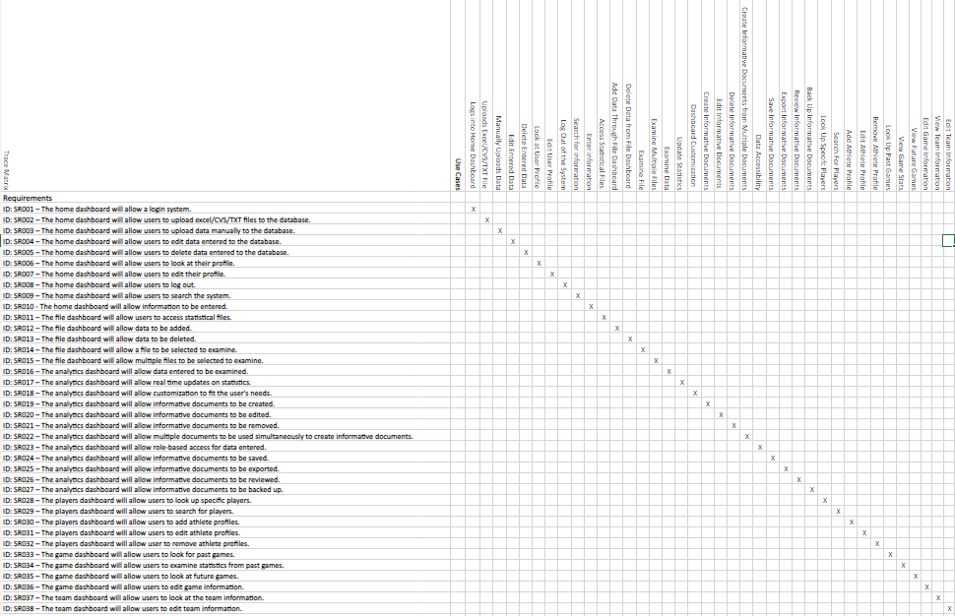

**Initial Architecture Considerations**

The architecture design of a system is very important for a business. Understanding how the processes work and how a system will flow can help show how the system will work. The design and realization viewpoint will show how the system will be constructed. The design view will show the basics of the system, it will contain users and connected to them will be the login system, then the content management system, and then all the different dashboards. The realization point of view contains the actual process that we will use for the system. Silverstripe is our content management system that we will be using. All these parts come together to create our new system.

Design Viewpoint:

Realization Viewpoint:

**Team Charter**

Introduction:

This team charter supplies a clear and concise description of how the project team will conduct its activities as a unit. The team charter will outline the team's goals, meetings, communications, decision-making process, and project repository. The goal of this charter is to ensure effective and efficient teamwork, improve the quality of project deliverables, and achieve project success.

Team Goals:

The project team's main goal is to complete the project successfully, delivering high-quality results that meet the client's expectations. The team also aims to maintain a positive and supportive work environment where team members can collaborate effectively and share their expertise.

Team Meetings:

The team will schedule regular meetings to discuss progress, share updates, and make decisions. Meetings will be scheduled and announced in advance, and all team members are expected to attend. Meetings will be conducted professionally, and decisions made during them will be documented and shared with all team members.

Team Communications:

The team will communicate regularly and openly to ensure that all team members are informed and involved. Ideas, technical materials, and decisions will be shared through a variety of channels, including email, instant messaging, and in-person meetings. The team will also regularly communicate with the client to keep them informed of progress and seek their input as needed.

Team Decisions:

The team will build consensus and make decisions through open and honest communication. In the event of conflicts, the team will work together to find a resolution that is in the best interest of the project and all stakeholders.

Project Repository:

The team will maintain a centralized project repository to ensure that all project documentation is easily accessible and organized. The repository will include all project deliverables, meeting minutes, and other relevant materials. The repository will be regularly updated and maintained to ensure that all team members have access to the most up-to-date information.

Conclusion:

The team charter provides a clear and concise guide for the project team, ensuring that all team members are on the same page and working towards a common goal. By following this charter, the team will be better equipped to complete the project successfully and deliver high-quality results that meet the client's expectations.

**Agile Stories**

ID: 1201  
Title: Secure Login  
As a: System User  
Workflow (I want to): securely log into the system  
Benefitted (so that): I can access my account information  
When I enter my credentials, this happens: the system verifies my identity and grants access to my account information.  
  
ID: 1202  
Title: User Account Management  
As a: System Administrator  
Workflow (I want to): manage user accounts  
Benefitted (so that): I can maintain the security of the system  
When I access the user account management panel, this happens: I am able to add, edit, or delete user accounts and their permissions.  
  
ID: 1203  
Title: Data Import

As a: System User/Admin  
Workflow (I want to): import player data

Benefitted (so that): I can insert data from other sources into our database  
When I access the import section, this happens: I am able to select the data category to import into and upload a file (CSV/Excel) to load data into the system.

ID: 1204  
Title: Dashboard Viewing  
As a: System User  
Workflow (I want to): easily analyze/summarize data  
Benefitted (so that): I can easily perform high-level analysis  
When I access the dashboards page, this happens: I am able to select the type of dashboard I want, view the information within it, and export/print the dashboard as needed.

**Gantt Chart**

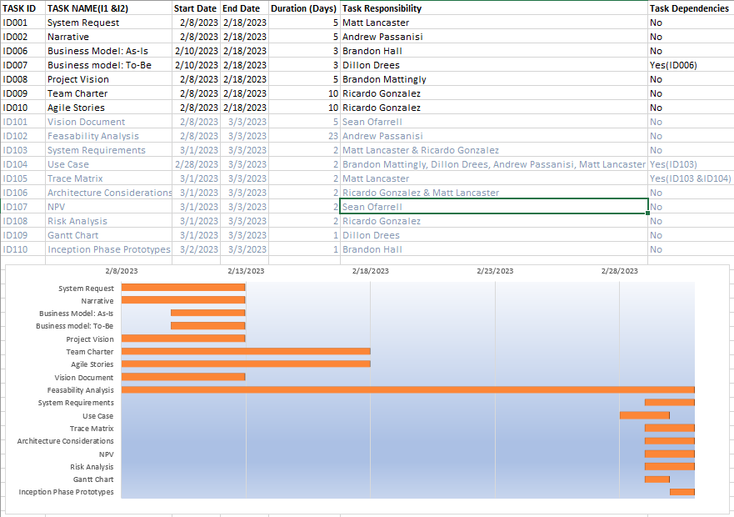

**Inception Phase Prototype**

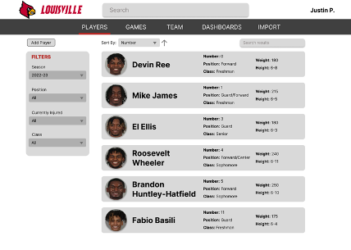

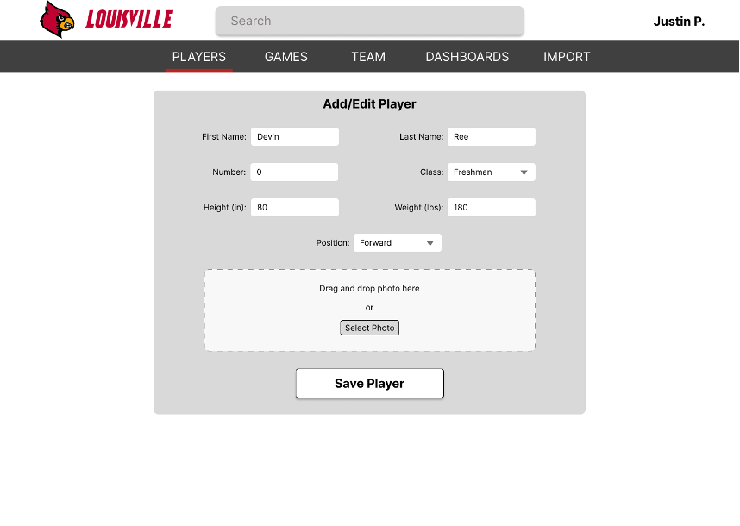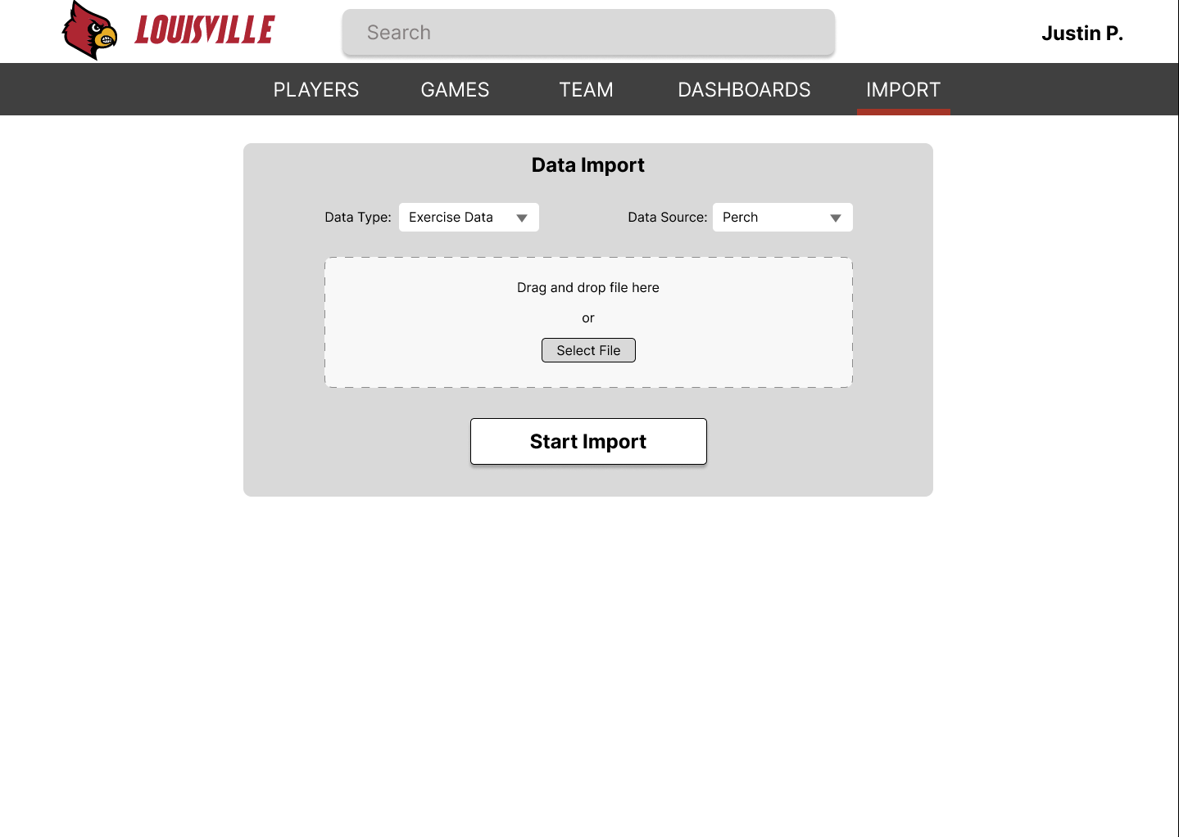

# 8. Appendix A

## 8.1 NPV Analysis

This is the financial analysis of the investment into the SilverStripe CMS database for the University of Louisville men’s basketball program. The spreadsheet begins with the revenue of the team, including the contributions, media rights, distributions, ticket sales, royalties, parking and concessions. This information was given to us and was regarding the 2020 season, but it is the most recent revenue breakdown available with the team revenue being $40,900,000. The contribution and guarantee take up the majority of the revenue given to the team sitting around 52% followed by ticket sales which takes up 29%. Most revenue sources only include about 1-3% of the revenue but it is still a large amount of money considering the massive revenue total.

This centralized database is intended to improve the team’s performance, and in turn help get the team more wins, which tend to draw a larger crowd. We assumed that ticket sales along with the parking and concessions revenues will grow at a 3% rate for the first three years and at a 5% rate for the following two years. This will raise the total ticket sales to $14,289,320 in year five of the project, which is about a $2,500,000 increase in just five years. The royalties, sponsorships, advertising, and licensing are assumed to grow at a rate of 2% per year due to higher team success which brings forth a larger audience to market their products too. Although some sources of revenue will grow, others will not be due to the team’s performance having no real impact on the growth of the income including distributions, contributions, and media rights.

The estimated expenses for the 2022-2023 season were $5,781,423, which is a small loss when considering how much revenue the team brings to the University of Louisville. We have anticipated a one-time sunk cost of $700, which will help introduce the team to the new database and how-to plug-in information properly as well as give the selected personnel who will have full/temporary access to the database. Along with the one-time training cost there will be a monthly fee of $425, which adds up to $5,100 per year. This is a small cost considering the potential growth of the team as well as the actual revenue of the program.

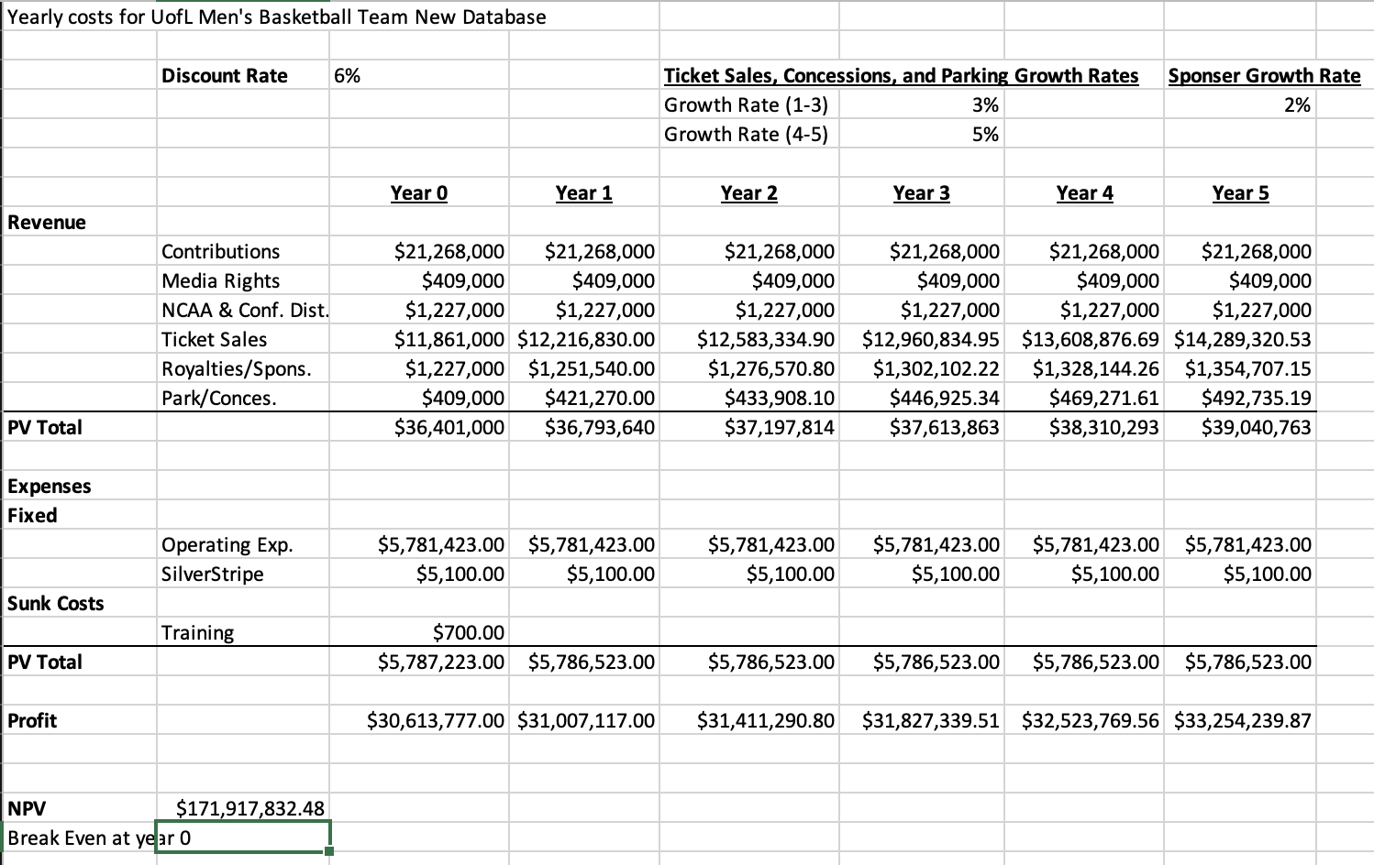

In I2 you should deliver what the deliverable documnet asked for. Why you add business need ... in I2?

Still there is "bold" word without reason!

--In economic feasibility section,you need to mention that "Appendix A shows the detail"

~~Name for Use case 2 can be : Upload datafile~~

--primary actors for use cases related to statistics, examine... should be coaches, and so instead of an administrator, you can have a "website user."

FYI: website users in this project are coaches.

So keep the primary actor for the use cases that are about entering data and editing data ... as" administrator" and for use cases for doing analysis... as "website user"

--Use Icons for architectures

--Make sure you add link for NPV and GanttChart for the next submission.

-- In NPV, make sure for the inception phase to edit your NPV since all income categories can not increase by 5%. Go with the most logical percentage. If you look at the initial percentage, each category increase by a certain/different amount. So make proper changes.